CAP276: Data Communication and Networking – Laboratory
Online Assignment-1
Note:
- Students can check the set assigned to them using following UMS link “UMS Navigation->LMS->Practical->Practical Upload”
- Every student will strictly perform the set assigned to him/her.
- Student should answer the practical question assigned to them in the format given in annexure-1.
- Convert your completed response document in PDF format and then upload it through the link “UMS Navigation->LMS->Practical->Practical Upload->Select File”.

SET-A
Design a network topology with a bus backbone connected to star, ring and mesh topologies. (Note every topology must have minimum four hosts in it).

SET-B
Design a network topology with a star backbone connected to bus, ring and mesh topologies. (Note every topology must have minimum four hosts in it).

SET-C
Design a network topology with a mesh backbone connected to star, ring and bus topologies. (Note every topology must have minimum four hosts in it).

SET-D
Design a network topology with a ring backbone connected to star, bus and mesh topologies. (Note every topology must have minimum four hosts in it).

SET-E
Design a network topology with a tree backbone connected to star, ring and bus topologies. (Note every topology must have minimum four hosts in it).

Annexure-1
Answer Sheet
Online Assignement-1
Course Code: | CAP 276 |  |  | Course Title: |  | Data Communication and Networking-Laboratory
Course Instructor: Avinash Bhagat
Student’s Roll no: |  |  |  |  |  | Student’s Reg. no:
Name:
Set Assigned (Tick): |  |  | A/B/C/D/E |  | Page No. |  |  | Total Pages

- Objective (Description of the practical to be performed):
________________________________________________________________________________________________________________________________________________________________________________________________________________________________________________________________________________________________________________________________

- Network Snapshot with proper labelling:
(Sample network is pasted here)
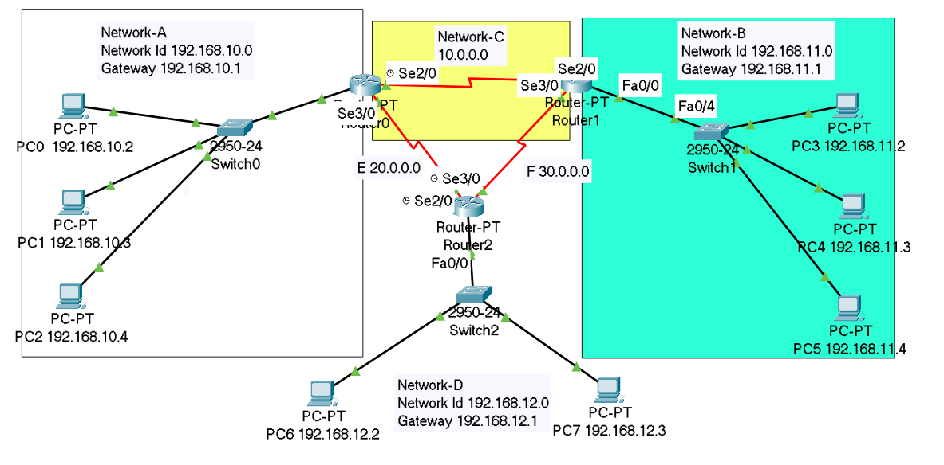
- Initial IP Configuration:
(Complete the table for all the devices according to the sample given)
Device | Interface | IP Configuration | Connected with
PC0 | Fa0 | 192.168.10.2 | Switch0
PC1 | Fa0 | 192.168.10.3 | Switch0
PC2 | Fa0 | 192.168.10.4 | Switch0
Switch0 | Fa0/4 | ----- | Router0
Router0 | Fa0/0 | 192.168.10.1 | Switch0
Router0 | Se2/0 | 10.0.0.1 | Router1
Router0 | Se3/0 | 20.0.0.1 | Router2

- Process Description:

Step-1

Step-2

.
.
.
.
.
.

